**COMPARISON BETWEEN SELECTION ALGORITHMS & MUTATIONS**

Crossover: single_point_xo Pop=500 Gens=300 10 runs

**FPS 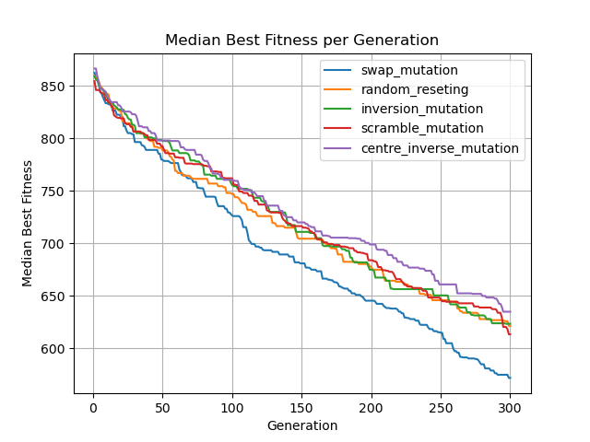 bf=555**

**Rank 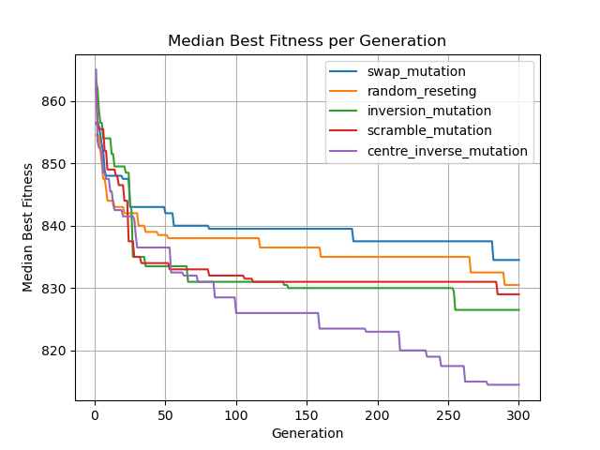 bf=788?**

**Tournament 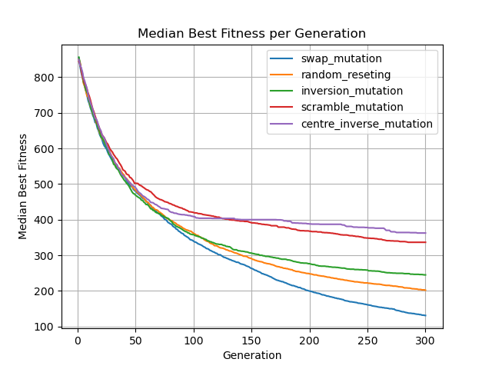 bf= 122**

**FPS RANK TOURNAMENT**

